Les Vants Aerial Photos
Cooper Airfield ~ NH07
49 East Cooper Street
Loudon, NH 03307
797-851-3431
www.lesvants.com jford@lesvants.com

Dear Client,

Les Vants Aerial Photo Service maintains two types of aerial photography libraries;

The 1st is our Stock File Library. Aerials of general interest taken in the New England area. These files are available to the public for reproduction. Many of our stock images can be found on our website, most of our 200,000+ images however are not online due to server restraints but proofs will be sent to you at your request.

The 2nd library we maintain is our Client File Library. These are aerial images we have been commissioned to shot for individual clients, such as yourself, with the understanding and promise of strictest confidentiality. Les Vants Aerials maintains total privacy in regard to these commissioned flights and images; they are not available to the public and / or other business interests.

If you come across one of our “commissioned” images in a brochure, website advertisement, etc and would like a copy of that image it will be up you to track down the owner of that image and request that they contact Les Vants Aerials to release their reproduction rights. We can not and will not furnish information in regards to the particular site or who commissioned us to acquire the photography.

Thank you for your understanding,

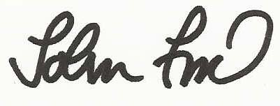

John Ford, Owner, Les Vants Aerial Photos

